Disposal Report
Contents
1. Description 1
2. Disposal report on Snow 1
3. Checks on report extracted in Excel format (periodical+final) 2
4. Checks on report extracted in Excel format (final report) 3

Description
In this document it is explained how/when to create and control the disposal

Disposal report on Snow
Every First working day of month we have to execute the report” ** ZEUS ** Asset Mgmt - Disposal Report - ITALY -” and send it to ENEL ASSET MANAGEMENT.
Before this we have to periodically check the content of the same in order not to arrive at the first of the month with large quantities of checks or corrections to be performed.
It is highly recommended to keep the versions previously processed so as not to have to redo the same checks. When we do this check the value on “retired date” on is equal to “this month”. When we do export to send to ENEL ASSET MANAGEMENT the value will be “Last month”.
Every time we proceed to manage the report, we have to export the list of assets from the “** ZEUS ** Asset Mgmt - Disposal Report - ITALY -” report, in order to check for any changes to the assets.

Checks on report extracted in Excel format (periodical+final)
These checks must be done at least 2 times a month before the production of the final report. For example, the first around the 15° day of the month and the second on 26° day. This is in order to not arrive at the first of the following month with numerous or unsolvable situations to be verified.
Create new columns (Col. R “Notes”; Col. S “Smartphone WFM 0,50”; Col. T “Price”; Col. U “Verifica AC 2018”; Col. V “Verifica AC 2019”; Col. W “WFM Riscatti”)
Font must be Calibri 11.

- Verify that Installation Date (col.D “Installed”) that must be contain a value
If we found an empty value but cost is 0 (col. O “cost”) it is ok
If we found an empty value but cost is not 0 (col. O “cost”) ask to ENEL ASSET MANAGEMENT

- Filter on row with “substate” (col.E) equal “Disposed” and check “Disposal reason” (col.F).:

- “Request by user”, normally are for “Fixed Telephony line” and have cost and loan cost =0 if different must be reported to ENEL asset Management.
- “Utenza disattivata” or “Subentro aziendale privato” or “Utenza inattiva” must be for “Model category” col. H equal to “Mobile line and data”. If found value ad “Mobile devices” must be reported to ENEL asset management.
Check also column O “Cost” that must have value 0 for enel company or 17 Eur. For others company like Mobile operator (Tim,Wind,Vodafone,Telecom)
- “REGOLARIZZAZIONE ASSET FUORI PERIMETRO ENEL” must be excluded from the report.
- “Asset da cancellare - Ordine cancellato” must be excluded from the report.

- Filter on row with “substate” (col.E) equal “Lost” and check “Disposal reason” (col. F).:
- Check that all assets declared as Lost have a corresponding document of LOST (not STOLEN).
If found an error must be correct on the asset (example STOLEN in place of LOST). Report any corrections to ENEL ASSET MANAGEMENT (only check these two columns)

- Filter on row with “substate” (col.E) equal “Stolen” and check “Disposal reason” (col. F).:
- Check that all assets declared as Lost have a corresponding document of STOLEN (not LOST)
If found an error must be correct on the asset (example LOST in place of STOLEN). Report any corrections to ENEL ASSET MANAGEMENT (only check these two columns)

- Filter on row with “substate” (col.E) equal “Sold” and check “Disposal reason” (col. F) must have
“Asset Purchase by Employee” - if different must be reported to ENEL asset Management.

- Check that field “Retired date” col. “K” is referred only on the month under check

- Check that field “Effective Retired date” col. “M” has for all row values and no empty value

- Check “Accounting company” col. “L” and select all company that are not ENEL, for example Tim, Wind, Vodafone, Telecom must have in column O “Cost” value 0 or 17 Eur. If we found different values must be reported to ENEL asset management. Also check that for empty accounting companies the cost is 0, if different from 0, report to ENEL ASSET MANAGEMENT.

- Check “Expenditure type” col. Q
This field may contain:
- Empty value: if cost = 0 we do nothing in the opposite case insert a note to report to ENEL ASSET MANAGEMENT
- “Opex”: Apply filter on column O “Cost”, we do nothing for cost =0 or =17 eur, instead for the different costs we insert the note for each line in column R “Notes” -> “Opex to be eliminated”

- Check for year 2018 to 2026 in Col. D “Installed” date for asset that have a Cost (col.O) not equal 0 or 17 (keep this filter for all 10.x paragraph).
- Execute report on SNOW “Asset price” by copying and pasting the AST NUMBER (only for assets with install date between 2018 and 2025).
- Do vertical lookup (search ast number) and insert the Value price True (that you found in the report year 2018...2026) in a new column named T “Price”.
- For asset that have asset price (col.T) that have value 0 or not value must be reported to ENEL ASSET MANAGEMENT.
- For Years 2018 and 2019 create 2 new columns in position U & V named “Verifica AC 2018” and “Verifica AC 2019”. Do vertical lookup with files “EUS_fatturazione ALL 2018” and “EUS_fatturazione ALL 2019” by filter on installed date 2018 or 2019 and search AST. Report the name of Company that are present in column B.
- Only from year 2020 to 2026 (install date): For asset with Accounting company (col. L) = “Enel Global Services Srl” or “ESDI_Share_Services” – we must keep the Cost, then put in column R (note) “no price”.
- Only for years 2018 and 2019, If a company is equal to “Enel Italia srl” or “ESDI_Share_Services” in column U or V, put “no price” in the corresponding column “note”.
- Remove the filter in column L, U and V. Filter on column R (Note) by selecting empty values and put “value price” in column R (Note) (for other assets that have a price different from 0 or 17).

- Match all asset with a excel sheet “Fatturazione WFM_e_distribuzione”
In Enel site:
To do that insert new column (S) named “Smartphone WFM 0,50” and do a vertical lookup matching AST NUMBER (col. C to with col.Z in file “Fatturazione WFM_e_distribuzione” )
If found/match leave the ASTNUMBER in column S and put in the corresponding column R (Note) the phrase “change to 0,50 and install date to 31/03/2019”.

- Match all asset with a excel sheet “WFM_Riscattati_2025”
If found/match leave the ASTNUMBER in column S and put in the corresponding column R (Note) the phrase “change to 8,05€ and install date to 01/08/2025”

- Save and keep this Excel for further checks or final report.

Checks on report extracted in Excel format (final report)
These checks must be done only on the final report.
- Duplicate the column “Cost” and insert it in the position of col. N and mark it in Yellow (so we have col. N “Cost” (marked in yellow); col. O “Loan Cost”; Col. P “Cost”; ecc..
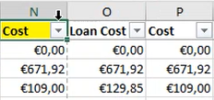

- Apply a filter on col. Q “Old asset ID” and select only fields with a value.
Substitute values in col N for each field with the value in corresponding column O “Loan cost”
Example:
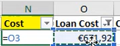
After substitution paste and copy all values in column N (Cost background color yellow) as values (123).

- Remove all filter and apply new filter on column Notes by selecting one by one and do corresponding actions:
- “Opex to be eliminated” -> remove the corresponding row
- remove filter and filter only for “value price” in column S -> insert these values on corresponding row/column in field “cost with background color yellow” (copy values in column price (U) in column (N) cost).

- Remove all filter and apply new filter on column T (smartphone WFM) and then on col. X (WFM Riscatti) by selecting values equal to
- Col. T: “Change to 0,50 and install date to 31/03/2019”. If found insert 0,50 on corresponding row/column in field “cost with background color yellow” and change “Installation date” to 31/03/2019.
- Col. X: “Change to 8,05 and install date to 01/08/2025”. If found insert 8,05 on corresponding row/column in field “cost with background color yellow” and change “Installation date” to 01/08/2025.

- Remove all filters and delete column from column O to column W as for below example:
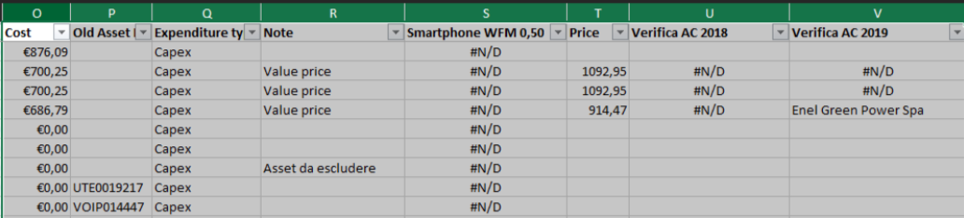

- Insert a new column in the first position, then open an old report (for example the previous month) and copy and paste the first row on actual report. Example:

On first row enter progress line numbers (from 1 to ...)

- Select the whole sheet and apply format “Calibri” as type of character and “8” as a dimension.

- Save the final report and send it to ENEL ASSET MANAGEMENT.

